

Semester Two Examination, 2018

Question/Answer booklet

MATHEMATICS

SOLUTIONS
APPLICATIONS
UNITS 3 AND 4

Section Two:

Calculator-assumed

Student number: In figures

In words

Your name

Time allowed for this section
Reading time before commencing work: ten minutes
Working time: one hundred minutes

Materials required/recommended for this section
To be provided by the supervisor
This Question/Answer booklet
Formula sheet (retained from Section One)

To be provided by the candidate
Standard items: pens (blue/black preferred), pencils (including coloured), sharpener,
correction fluid/tape, eraser, ruler, highlighters

Special items: drawing instruments, templates, notes on two unfolded sheets of A4 paper, and up to three calculators approved for use in this examination

Important note to candidates
No other items may be taken into the examination room. It is your responsibility to ensure that you do not have any unauthorised material. If you have any unauthorised material with you, hand it to the supervisor before reading any further.

Structure of this paper

Section | Number of questions available | Number of questions to be answered | Working  time (minutes) | Marks available | Percentage of examination
Section One:  Calculator-free | 7 | 7 | 50 | 51 | 35
Section Two:  Calculator-assumed | 12 | 12 | 100 | 99 | 65
 |  |  |  | Total | 100

Instructions to candidates

1. The rules for the conduct of examinations are detailed in the school handbook. Sitting this examination implies that you agree to abide by these rules.

2. Write your answers in this Question/Answer booklet.

3. You must be careful to confine your response to the specific question asked and to follow any instructions that are specified to a particular question.

4. Supplementary pages for the use of planning/continuing your answer to a question
have been provided at the end of this Question/Answer booklet. If you use these pages to continue an answer, indicate at the original answer where the answer is continued, i.e. give the page number.

5. Show all your working clearly. Your working should be in sufficient detail to allow your answers to be checked readily and for marks to be awarded for reasoning. Incorrect answers given without supporting reasoning cannot be allocated any marks. For any question or part question worth more than two marks, valid working or justification is required to receive full marks. If you repeat any question, ensure that you cancel the answer you do not wish to have marked.

6. It is recommended that you do not use pencil, except in diagrams.

7. The Formula sheet is not to be handed in with your Question/Answer booklet.

Section Two: Calculator-assumed 65% (99 Marks)
This section has twelve (12) questions. Answer all questions. Write your answers in the spaces provided.

Working time: 100 minutes.

Question 8 (6 marks)
The deseasonalised number of working holiday makers in Australia over the four-year period from March 2014 to December 2017 was modelled by $n=160.74-1.382t$, where $n$ is the number of people in thousands and $t$ is the quarter, with $t=1$ corresponding to March 2014.

The Seasonal Index table is shown below.

Quarter | March | June | September | December
Seasonal Index | $$1.07$$ | $$x$$ | $$0.96$$ | $$1.02$$

(a) Determine the value of $x$ in the table above. (1 mark)
Solution
$$x=4-1.07-0.96-1.02=0.95$$

Specific behaviours
correct value

(b) State, with reasons, whether the number of working holiday makers in Australia was highest during September 2017 or during September 2014. (2 marks)
Solution
Sept 2014, as the gradient of the linear model is $-1.382$, indicating a decrease of 1382 people per quarter.

Specific behaviours
chooses correct year
✓ indicates gradient implies decrease over time

(c) Use your knowledge of time series to estimate the actual change in the number of working holiday makers in Australia from December 2017 ($t=16)$ to March 2018 ($t=17)$.
(3 marks)
Solution
$$\left[160.74-1.382\left(16\right)\right]×1.02=138.6×1.02=141.40$$

$$\left[160.74-1.382\left(17\right)\right]×1.07=137.2×1.07=146.85$$

$$146.9-141.4=5.45⇒\text{Increase of} 5 450 \text{people}$$

Specific behaviours
correct prediction for $t=16$ in $000$'s
✓ correct prediction for $t=17$ in $000$'s
✓ correct change, adjusting for $000$'s

Question 9 (6 marks)
(a) A connected planar graph has $11$ faces and $7$ vertices. Determine how many edges must be removed from the graph to leave the minimum spanning tree. (3 marks)
Solution
$$\text{CPG}: e=11+7-2=16$$

$$\text{MST}:e=1+7-2=6$$

Hence 10 edges must be removed.

Specific behaviours
indicates edges in graph
✓ indicates edges in MST
✓ states difference

(b) The vertices in the graph below represent activity centres in a theme park and the edges represent various footpaths between the centres. The weights on the edges represent the time to travel along that footpath. Identify the minimum spanning tree on the graph and state its length. (3 marks)
Solution
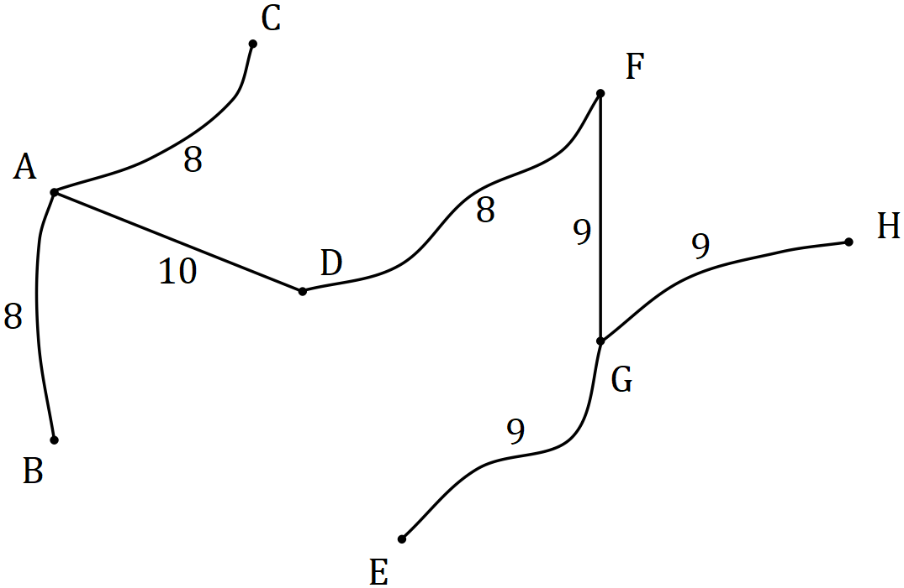

$$L=8+8+10+8+9+9+9=61 \text{minutes}$$

Specific behaviours
tree with 7 edges
✓ correct MST highlighted/shown
✓ correct length

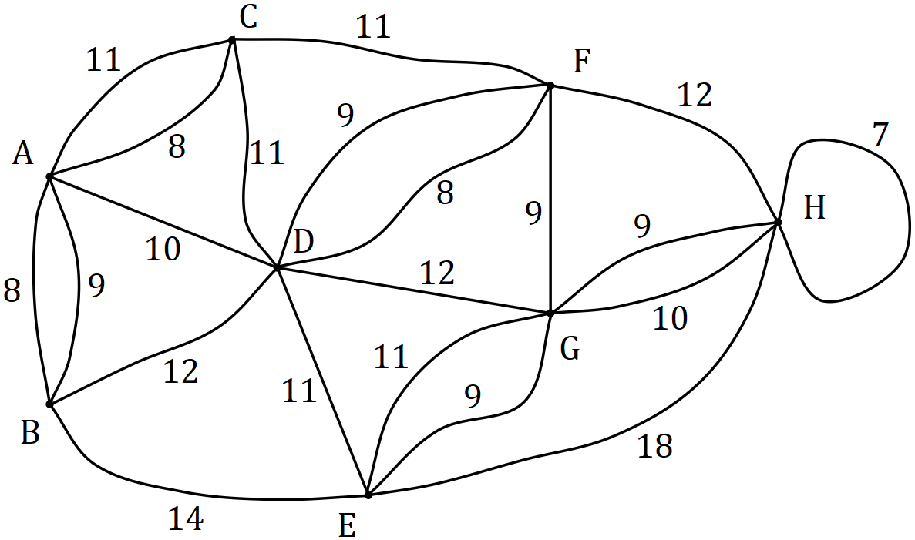

Question 10 (8 marks)
The data in the table below was collected by a student who was investigating whether an association exists between a person's hair and eye colour. The observations were taken from a survey of $64$ people.
 |  | Eye colour
 |  | Blue-Green | Brown
Hair colour | Black | $$0$$ | $$11$$
 | Blond | $$16$$ | $$13$$
 | Brown | $$4$$ | $$20$$

(a) What percentage of the people surveyed had brown eyes? (1 mark)
Solution
$$44÷64=69\%$$

Specific behaviours
correct percentage

(b) What percentage of the brown eyed people had blond hair? (1 mark)
Solution
$$13÷44=30\%$$

Specific behaviours
correct percentage

(c) Complete the table of column percentages below. (2 marks)
Solution
See table
Specific behaviours
one column correct
✓ both columns correct

 |  | Eye colour
 | % | Blue-Green | Brown
Hair colour | Black | $$0$$ | $$25$$
 | Blond | $$80$$ | $$30$$
 | Brown | $$20$$ | $$45$$

(d) Does the data suggest the presence of an association between the categorical variables? Justify your answer using figures from the percentage table. (2 marks)
Solution
Yes, as the two percentages in each row are quite different. For example, 45% of brown eyed people have brown hair but only 20% of those with blue-green eyes have brown hair.

Specific behaviours
yes to association
✓ uses appropriate percentages to justify

(e) One of the conclusions made by the student was that having black hair caused a person to have brown eyes. Comment on this conclusion. (2 marks)
Solution
This conclusion is not valid. An observed association does not mean there is a causal relationship between the variables.

Specific behaviours
indicates conclusion not valid
comments on causality

Question 11 (6 marks)
Spectators leave a sports ground $C$ and walk to a train station $F$along footpaths in the directions shown on the network below. The weights on the edges represent the maximum number of people who can safely travel along each footpath, in hundreds of people per minute.

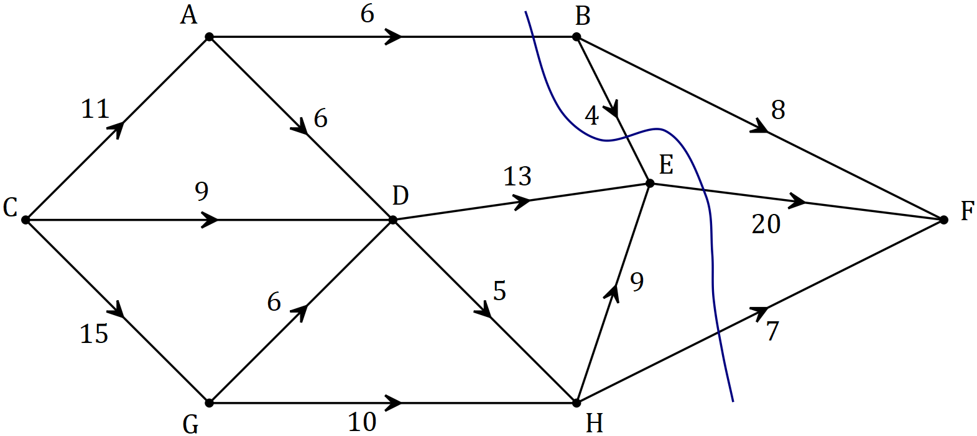

(a) By listing the different paths and their corresponding flow rates, determine the maximum number of people that can walk through the network from $C$ to $F$ every minute. (4 marks)
Solution
CABF = 6
CADEF = 5
CDEF = 8
CDHEF = 1
CGDHEF = 4
CGHEF = 2
CGHF = 7

Total flow = 33, hence maximum of 3 300 people per minute.

Specific behaviours
correctly shows at least two paths with flow contributions
✓ correctly shows all paths with flow contributions
✓ correct total flow
✓ correctly states the maximum flow in people per minute

(b) Verify your answer from part (a) by showing the minimum cut on the network above and showing in the space below how to determine the capacity of the cut. (2 marks)
Solution
See graph. NB Flow $B→E$ is reversed.

Capacity of cut: $6+(-4)+20+7=33$

Specific behaviours
cut clearly shown on graph
✓ correct values used to obtain capacity

Question 12 (9 marks)
At the start of January an annuity was set up with a sum of $\$440 000$. At the end of each month, interest on the balance at the start of the month was added and then $\$3 350$ was withdrawn. The table below illustrates this process.

Month, $n$ | Balance at start of month, $T_{n}$ | Interest for month | Withdrawal | Balance at end of month, $T_{n+1}$
$$1$$ | $$\$440 000.00$$ | $$\$2 420.00$$ | $$\$3 350.00$$ | $$\$439 070.00$$
$$2$$ | $$\$439 070.00$$ | $$\$2 414.89$$ | $$\$3 350.00$$ | $$\$438 134.89$$
$$3$$ | $$\$438 134.89$$ | $$\$2 409.74$$ | $$\$3 350.00$$ | $$\$437 194.63$$
$$4$$ | $$\$437 194.63$$ | $$\$2 404.57$$ | $$\$3 350.00$$ | $$\$436 249.20$$
$$5$$ | $$\$436 249.20$$ | $$\$2 399.37$$ | $$\$3 350.00$$ | $$P$$
$$6$$ |  | $$Q$$

(a) Show how to use values from the table to deduce that the annual interest rate is $6.6\%$.
(2 marks)
Solution
Monthly rate: $2420÷440000=0.0055$
Annual rate as %: $0.0055×12×100=6.6\%$

Specific behaviours
shows monthly rate calculation
✓ shows conversion to annual rate calculation

(b) The linear recurrence relation for the balance of the annuity at the start of month $n$ has the form $T_{n+1}=aT_{n}-b, T_{1}=c$. State the values of $a$, $b$ and $c$. (2 marks)
Solution
$$a=1.0055, b=3 350, c=440 000$$

Specific behaviours
value of $a$
✓ values of $b$ and $c$

(c) Determine the values of $P$ and $Q$ in the table. (2 marks)
Solution
$$P=\$435 298.57, Q=\$2 394.14$$

Specific behaviours
value of $P$
✓ value of $Q$

(d) Determine the balance of the annuity at the end of month $120$ and calculate the total interest that the annuity has earned over the first $120$ months. (3 marks)
Solution
$$T_{121}=\$282 526.20$$

$$I=282 526.20+120×3 350-440 000=\$244 526.20$$

Specific behaviours
correct balance
✓ calculates total withdrawals
✓ correct total interest

Question 13 (11 marks)
To investigate the hypothesis that the mass of sugar, $w$ grams, that will dissolve in $300$ ml of water changes with the temperature, $t°C$, of the water, a student collected the results shown in the table below.

$$t$$ | $$25$$ | $$30$$ | $$35$$ | $$40$$ | $$45$$ | $$50$$ | $$55$$ | $$60$$ | $$65$$
$$w$$ | $$254$$ | $$264$$ | $$289$$ | $$293$$ | $$319$$ | $$329$$ | $$351$$ | $$375$$ | $$393$$

(a) Identify the explanatory variable in this investigation. (1 mark)
Solution
Temperature

Specific behaviours
correct variable

(b) Calculate the correlation coefficient between temperature and mass of dissolved sugar and hence describe the direction and strength of the association between the variables.
(2 marks)
Solution
$$r=0.994$$

Association is strong and positive.

Specific behaviours
value to at least 2dp
✓ direction and strength

(c) Determine the equation of the least-squares line for predicting $w$ from $t$. (2 marks)
Solution
$$w=3.50t+161.2$$

Specific behaviours
gradient
✓ $y$-intercept

(d) Interpret, in context, the value of

(i) the $y$-intercept of the least-squares line in (c). (1 mark)
Solution
$161.2$ is the mass of sugar that will dissolve when the temperature of the water is $0°C$.

Specific behaviours
correct interpretation

(ii) the gradient of the least-squares line in (c). (1 mark)
Solution
For every $1°C$ increase in water temperature, an extra $3.5$ grams of sugar will dissolve.

Specific behaviours
correct interpretation

(e) Predict the mass of sugar that will dissolve in $300$ ml of water at a temperature of

(i) $34°C$. (1 mark)
Solution
$$w=280 \text{g}$$

Specific behaviours
correct value

(ii) $80°C$. (1 mark)
Solution
$$w=441 \text{g}$$

Specific behaviours
correct value

(f) Comment on the reliability of both predictions in (e). (2 marks)
Solution
The first prediction for $34°C$, is very reliable due to strong correlation and interpolation.

However, the second prediction for $80°C$ involves considerable extrapolation and should be treated with caution.

Specific behaviours
rates first as reliable with reasoning
✓ rates second as unreliable with reasoning

Question 14 (11 marks)
Aya deposits a fixed sum in her bank account each week so that its balance after $n$ deposits is given by $A_{n}$, where $A_{n+1}=A_{n}+\$3.50$, $A_{1}=\$59$.

(a) Determine

(i) the balance of Aya's account after $20$ deposits. (1 mark)
Solution
$$A_{20}=\$125.50$$

Specific behaviours
correct amount

(ii) the least number of deposits Aya must make so that the balance in her account exceeds $\$200$. (1 mark)
Solution
$$n=42$$

Specific behaviours
correct number

Starting at the same time as Aya, Bart withdraws a fixed sum from his bank account every week so that its balance after $n$ withdrawals is given by $B_{n}$, where $B_{n+1}=B_{n}-\$1.80$, $B_{1}=\$324$.

(b) Determine

(i) the $n$^{th} term rule for the balance of Bart's account after $n$ withdrawals. (2 marks)
Solution
$$B_{n}=324-1.8\left(n-1\right)$$

Specific behaviours
correct form; value of first term
✓ correctly shows $(n-1)$ multiplied by $-1.8$

(ii) the maximum number of withdrawals Bart can make until he has no money left.
(1 mark)
Solution
$$n=181$$

Specific behaviours
correct number

(c) Determine the value of $n$ so that $A_{n}=B_{n}$ and state the value of $A_{n}$ at this time. (2 marks)
Solution
$$n=51$$

$$A_{n}=\$234$$

Specific behaviours
correct value of $n$
✓ correct value of $A_{n}$

(d) Let $C_{n}$ be the combined balance, in dollars, that Aya and Bart have in their accounts after they have made $n$ deposits and $n$ withdrawals respectively.

(i) Show that $C_{5}=\$389.80$. (1 mark)
Solution
$$A_{5}=73, B_{5}=316.80$$

$$C_{5}=73+316.80=389.80$$

Specific behaviours
shows values of $A_{5}$ and $B_{5}$

(ii) The $n$^{th} term rule for $C_{n}$ is $C_{n}=an+b$. Determine the values of $a$ and $b$. (2 marks)
Solution
$$C_{1}=59+324=383 \\ C_{2}=383+3.50-1.80=383+1.70$$

$$C_{n}=383+1.7\left(n-1\right) \\ =383+1.7n-1.7 \\ =381.3+1.7n$$

$$a=1.7, b=381.3$$

Specific behaviours
indicates first term and common difference of sequence
✓ correct values

(iii) Determine the smallest value of $n$ for $C_{n}$ to exceed $\$525$. (1 mark)
Solution
$$n=85$$

Specific behaviours
correct value

Question 15 (8 marks)
(a) A company advertised compound interest of $15.6\%$ pa on investments of $\$250 000$ for a period of $5$ years. Calculate the total interest on the investment over this time. (2 marks)

Solution
$$I=250 000{\left(1.156\right)}^{5}-250 000 \\ =\$266 094.44$$

Specific behaviours
indicates calculation for future value
✓ correct interest

(b) Savings account A offers interest of $4.22\%$ pa compounded monthly and savings account B offers interest of $4.23\%$ pa compounded quarterly. Calculate the effective interest rate for both accounts and hence decide which savings account offers the better return.
(3 marks)
Solution
Account A: ${\left(1+0.0422\right)}^{12}-1=0.04 303=4.303\%$

Account B: ${\left(1+0.0423\right)}^{4}-1=0.04 298=4.298\%$

Account A offers the better return.

Specific behaviours
EIR for A
✓ EIR for B
✓ indicates account giving better return

(c) A philanthropist is considering funding $8$ scholarships to a local college. Each student in receipt of a scholarship would receive a payment of $\$6 000$ on the yearly anniversary of the creation of the fund. Determine, to the nearest $\$100$, the initial sum of money that should be deposited in an account paying interest at a rate of $3.6\%$ compounded monthly to create a perpetuity to fund all $8$ scholarships. (3 marks)
Solution
$$\text{EIR}={\left(1+0.036÷12\right)}^{12}-1=0.0366$$

$$I=8×6 000=48 000$$

$$P×0.0366=48 000 \\ P≈\$1 311 500$$

Specific behaviours
calculates effective interest rate
✓ calculates interest required
✓ solves for principal

Question 16 (8 marks)
A company recorded the distance travelled, $k$ in hundreds of km, and the amount of fuel used, $f$ litres, for the trucks in its fleet each day. The scatterplot below shows the data for one day, for which $r=0.938$ and the equation of the least-squares line is $f=44.9k+17.5$.

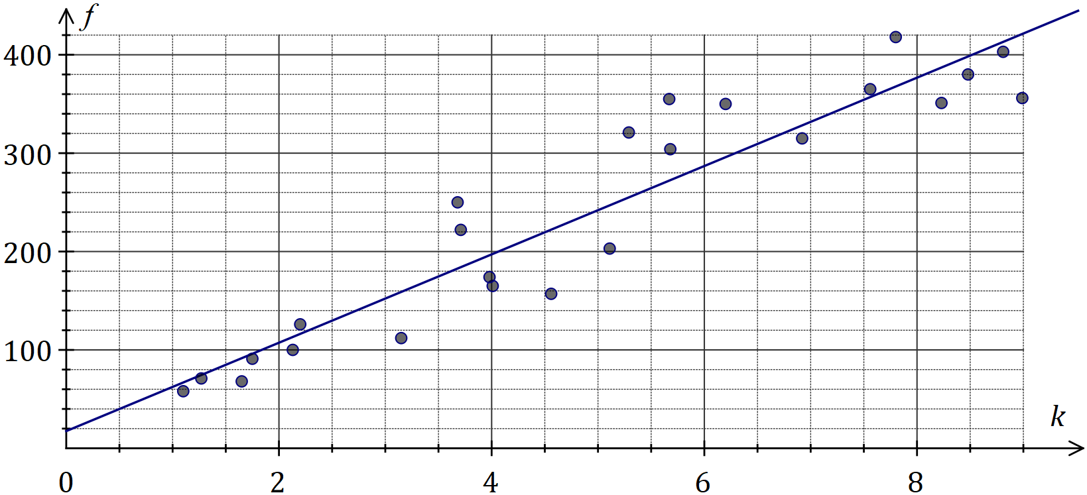
Solution (b)
See graph
Specific behaviours
reasonable straight line
✓ close to $(2, 110)$ and $(8, 380)$

(a) What percentage of the variation in the amount of fuel used can be explained by the variation in distance travelled? (1 mark)
Solution
$$r^{2}={0.938}^{2}=0.88⇒88\%$$

Specific behaviours
correct percentage

(b) Draw the least-squares line on the scatterplot above. (2 marks)

(c) Determine the residual for the data point $(4.56, 157)$ and add it to the residual plot below.
(3 marks)
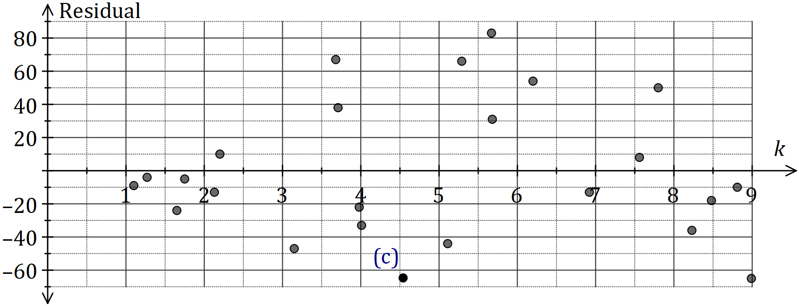
Solution
$$\hat{f}=44.9×4.56+17.5=222$$
$$\text{Residual}=157-222=-65$$
See graph for point
Specific behaviours
calculates $\hat{f}$
✓ calculates residual
✓ plots accurately

(d) Use the residual plot to comment on the appropriateness of fitting a linear model to the data. (2 marks)
Solution
Linear model IS appropriate, as no pattern evident in the residuals.

Specific behaviours
indicates appropriate
✓ supplies suitable reason

Question 17 (10 marks)
The time, $T$ minutes, a new driver spent delivering goods on the same city route is shown in the table and graph below.

Week | Day | Day number ($n$) | Time  ($T$) | $3$-day mean | Percentage of $3$-day mean | Deseasonalised time ($t$)
$$1$$ | Fri | $$1$$ | $$90$$ |  | $$111.1$$ | $$80.8$$
$$1$$ | Sat | $$2$$ | $$87$$ | $$81$$ | $$107.4$$ | $$81.9$$
$$1$$ | Sun | $$3$$ | $$66$$ |  | $$81.5$$ | $$80.1$$
$$2$$ | Fri | $$4$$ | $$87$$ |  | $$111.5$$ | $$78.1$$
$$2$$ | Sat | $$5$$ | $$83$$ | $$A$$ | $$106.4$$ | $$78.2$$
$$2$$ | Sun | $$6$$ | $$64$$ |  | $$82.1$$ | $$77.7$$
$$3$$ | Fri | $$7$$ | $$85$$ |  | $$B$$ | $$76.3$$
$$3$$ | Sat | $$8$$ | $$79$$ | $$76$$ | $$103.9$$ | $$74.4$$
$$3$$ | Sun | $$9$$ | $$C$$ |  | $$84.2$$ | $$77.7$$
$$4$$ | Fri | $$10$$ | $$79$$ |  | $$111.3$$ | $$D$$
$$4$$ | Sat | $$11$$ | $$76$$ | $$71$$ | $$107$$ | $$71.6$$
$$4$$ | Sun | $$12$$ | $$58$$ |  | $$81.7$$ | $$70.4$$

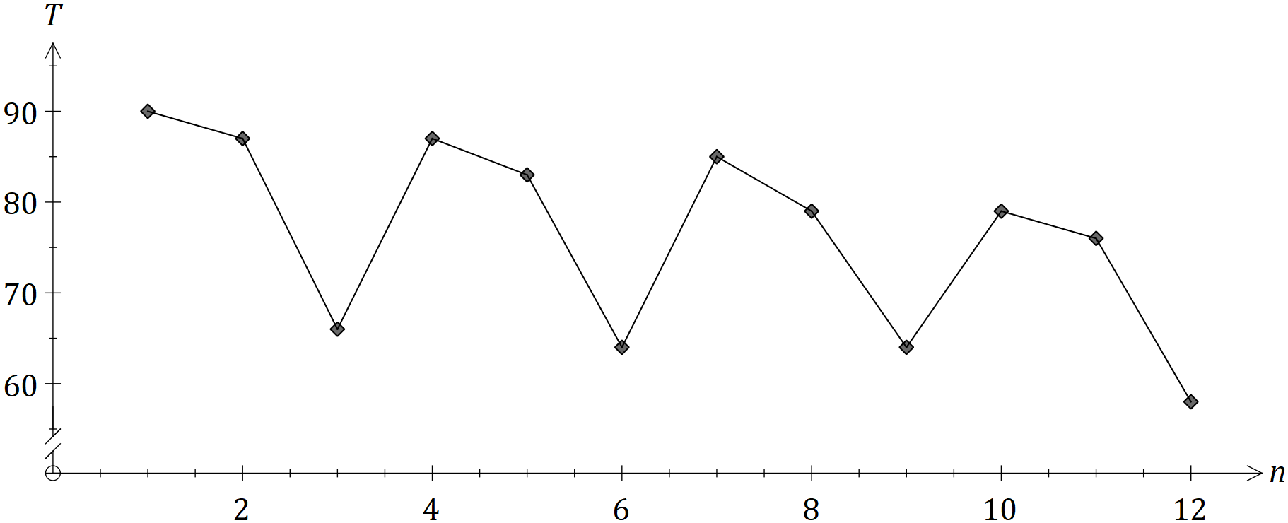

(a) Calculate the values of the entries A, B and C in the table. (3 marks)
Solution
$$A=\frac{87+83+64}{3}=78$$

$$B=\frac{85}{76}×100=111.8$$

$$C=84.2×76÷100=64$$

Specific behaviours
value of $A$
✓ value of $B$
✓ value of $C$

(b) Complete the Seasonal Index table below. (2 marks)

Day | Fri | Sat | Sun
Seasonal Index | $$1.114$$ | 1.062 | 0.824
Solution
$$Sat=\frac{107.4+106.4+103.9+107}{4×100}=1.062$$

$$Sun=3-1.114-1.062=0.824$$

Specific behaviours
one correct index
✓ both correct

(c) Calculate $D$, the deseasonalised value of $T$ for Friday of Week $4$. (2 marks)
Solution
$$t=79÷1.114=70.9$$

Specific behaviours
uses correct value of $T$ and index
✓ correct value of $t$

The equation of the least-squares line for $t$ against $n$ is $\hat{t}=83.0-1.001n$.

(d) Forecast the time $T$ that the driver will take on Friday of Week $5$ if the existing trend and seasonality continue. (3 marks)
Solution
$$n=13$$

$$\hat{t}=83.0-1.001\left(13\right)=70.0$$
$$T=70.0×1.114=78 \text{minutes}$$

Specific behaviours
correct value of $n$
✓ correct value of $\hat{t}$
✓ correct forecast for $T$

Question 18 (7 marks)
A project requires the following $10$ activities to be completed.

Activity | Immediate predecessor(s) | Time (weeks) |  | Activity | Immediate predecessor(s) | Time (weeks)
$$A$$ | $$C, L$$ | $$13$$ |  | $$F$$ | $$E$$ | $$9$$
$$B$$ | $$E$$ | $$29$$ |  | $$G$$ | $$C, L$$ | $$17$$
$$C$$ | $$\text{None}$$ | $$20$$ |  | $$H$$ | $$\text{None}$$ | $$8$$
$$D$$ | $$A, F$$ | $$21$$ |  | $$K$$ | $$G$$ | $$15$$
$$E$$ | $$\text{None}$$ | $$23$$ |  | $$L$$ | $$H$$ | $$14$$

(a) The network below represents the interdependencies of the above activities. Clearly label each edge with its activity and time. (3 marks)

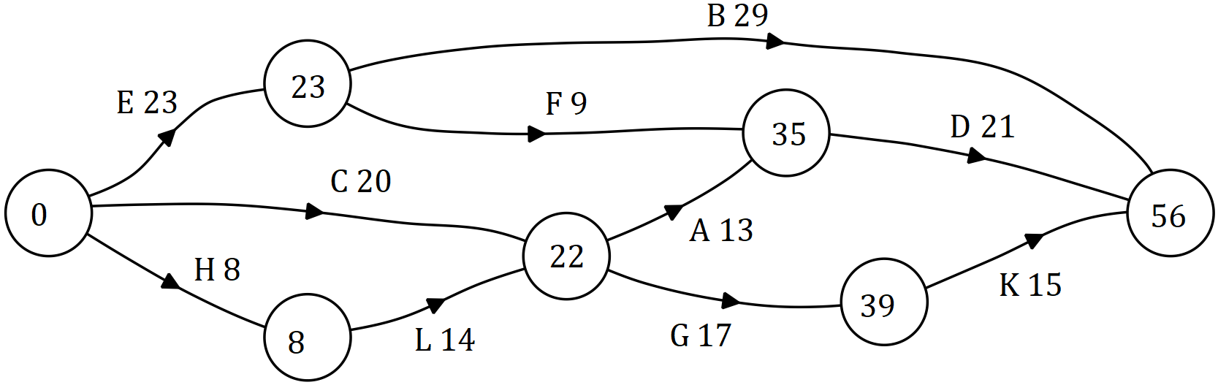
Solution
See graph (EST shown)
Specific behaviours
identifies edges $C, E, H$
✓ at least 7 correct labels
✓ all labels correct

(b) Identify the critical path and hence state the minimum time for the project to be completed. (2 marks)
Solution
$$\text{CP: }H-L-A-D$$

$$\text{MCT}=8+14+13+21=56 \text{weeks}$$

Specific behaviours
identifies critical path
✓ states MCT

(c) Determine the latest start time and float time for activity $F$. (2 marks)
Solution
$$LST=35-9=\text{Week} 26$$

$$\text{Float}=26-23=3 \text{weeks}$$

Specific behaviours
latest start time
✓ float time

Question 19 (9 marks)
A business loan of $\$120 000$ was taken out at the start of the first quarter of 2018. Interest, at a rate of $13.8\%$ per annum, was calculated on the balance of the loan on the last day of each month and added to the loan. Repayments of $\$12 410.64$ were made on the last day of each quarter, just after interest for the month was added.

(a) Calculate the interest added during the first quarter of 2018. (3 marks)
Solution
Monthly rate: $r=0.138÷12=0.0115$
After 3 months: $120 000×{1.0115}^{3}=124 187.79$
Total: $I=124 187.79-120 000=\$4 187.79$

Specific behaviours
indicates monthly interest rate
✓ indicates suitable method
✓ correct interest

(b) Determine
(i) the balance of the loan at the start of the second quarter of 2018. (1 mark)
Solution
$$\text{Balance}=120 000+4 187.79-12 410.64=\$111 777.15$$

Specific behaviours
correct balance

(ii) the number of repayments to fully repay the loan. (1 mark)
Solution
Using financial calculator, $N=12$

Specific behaviours
correct number

(iii) the total interest charged over the life of the loan, to the nearest dollar. (2 marks)
Solution
$$I=12×12 410.64-120 000=\$28 927.68$$
$$I\sim \$28 928$$

Specific behaviours
indicates total repaid
✓ correct interest (no penalty if not to nearest dollar)

(c) The business decided to halve the loan repayments, assuming that it would take twice as long to repay the loan. Write a brief note to the business commenting on the validity of this assumption. (2 marks)
Solution
Assumption not true because balances owing at the end of each quarter will be greater and so there will be additional interest, taking $33$ quarters to repay the loan.

Specific behaviours
explanation referring to extra time because of extra interest
✓ states actual time to repay loan

Supplementary page

Question number: _________

Supplementary page

Question number: _________

© 2018 WA Exam Papers. Kennedy Baptist College has a non-exclusive licence to copy and communicate this document for non-commercial, educational use within the school. No other copying, communication or use is permitted without the express written permission of WA Exam Papers. SN245-126-4.

